**Mission 1**

**Issue**: Due to the DoS attack, the Empire took down the Resistance's DNS and primary email servers.

* The Resistance's network team was able to build and deploy a new DNS server and mail server.
* The new primary mail server is asltx.l.google.com and the secondary should be asltx.2.google.com.
* The Resistance (starwars.com) is able to send emails but unable to receive any.

Your mission:

* Determine and document the mail servers for starwars.com using NSLOOKUP.
  + 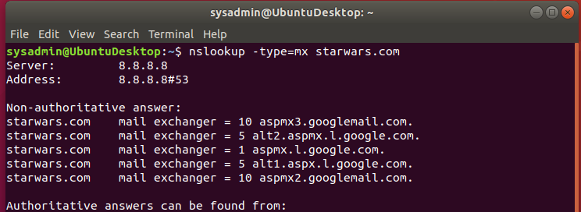
* Explain why the Resistance isn't receiving any emails.
  + The Resistance isn’t receiving any mail because aspmx.l.google.com is set as the primary mail server instead of asltx.l.google.com.
* Document what a corrected DNS record should be.
  + Starwars.com mail exchanger = 1 asltx.l.google.com
  + Starwars.com mail exchanger = 5 asltx.2.google.com

**Mission 2**

**Issue**: Now that you've addressed the mail servers, all emails are coming through. However, users are still reporting that they haven't received mail from the theforce.net alert bulletins.

* Many of the alert bulletins are being blocked or going into spam folders.
* This is probably due to the fact that theforce.net changed the IP address of their mail server to 45.23.176.21 while your network was down.
* These alerts are critical to identify pending attacks from the Empire.

Your mission:

* Determine and document the SPF for theforce.net using NSLOOKUP.
  + 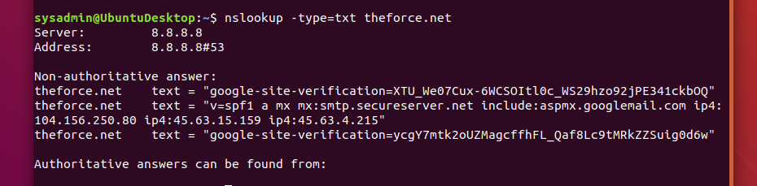
* Explain why the Force's emails are going to spam.
  + The Force’s email are going to spam because the new IP address of 45.23.176.21 is not in the record.
* Document what a corrected DNS record should be.
  + theforce.net text = "v=spf1 a mx mx:smtp.secureserver.net include:aspmx.googlemail.com ip4: 45.23.176.21 ip4: 104.156.250.80 ip4:45.63.4.215"

**Mission 3**

**Issue**: You have successfully resolved all email issues and the resistance can now receive alert bulletins. However, the Resistance is unable to easily read the details of alert bulletins online.

* They are supposed to be automatically redirected from their sub page of resistance.theforce.net to theforce.net.

Your mission:

* Document how a CNAME should look by viewing the CNAME of www.theforce.net using NSLOOKUP.
  + 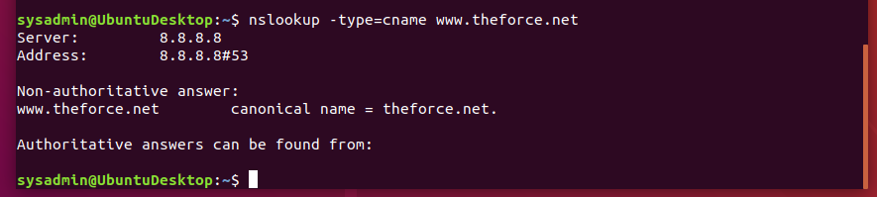
* Explain why the sub page of resistance.theforce.net isn't redirecting to theforce.net.
  + resistance.theforce.net isn’t list in the Cname records that why the sub page isn't redirecting to theforce.net.
* Document what a corrected DNS record should be.
  + resistance.theforce.net canonical name = theforce.net.

**Mission 4**

**Issue**: During the attack, it was determined that the Empire also took down the primary DNS server of princessleia.site.

* Fortunately, the DNS server for princessleia.site is backed up and functioning.
* However, the Resistance was unable to access this important site during the attacks and now they need you to prevent this from happening again.
* The Resistance's networking team provided you with a backup DNS server of: ns2.galaxybackup.com.

Your mission:

* Confirm the DNS records for princessleia.site.
  + 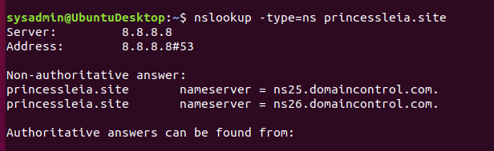
* Document how you would fix the DNS record to prevent this issue from happening again.
  + I would add the backup DNS server which is Nameserver = ns2.galaxybackup.com. to help.

**Mission 5**

**Issue**: The network traffic from the planet of Batuu to the planet of Jedha is very slow.

* You have been provided a network map with a list of planets connected between Batuu and Jedha.
* It has been determined that the slowness is due to the Empire attacking Planet N.

Your Mission:

* View the [Galaxy Network Map](/upenn-bootcamp/upenn-phi-cyber-pt-11-2020-u-c/raw/master/2-Homework/09-Networking-Fundamentals-II-and-CTF-Review/resources/Galaxy_Network_map.png) and determine the OSPF shortest path from Batuu to Jedha.
  + 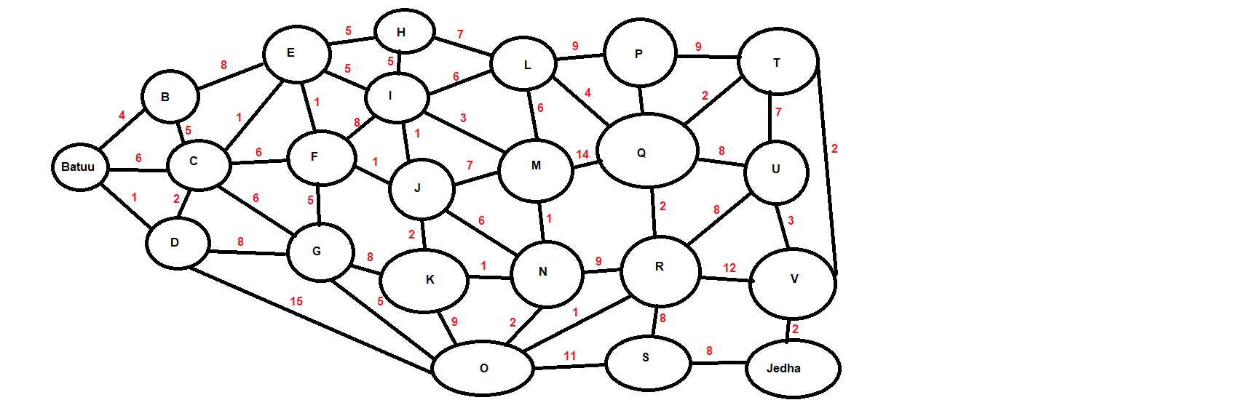
* Confirm your path doesn't include Planet N in its route.
* Document this shortest path so it can be used by the Resistance to develop a static route to improve the traffic.
  + Shortest path without N:
  + Batuu – D – C – E – F – J – I – L – Q – T – V – Jedha

**Mission 6**

**Issue:** Due to all these attacks, the Resistance is determined to seek revenge for the damage the Empire has caused.

* You are tasked with gathering secret information from the Dark Side network servers that can be used to launch network attacks against the Empire.
* You have captured some of the Dark Side's encrypted wireless internet traffic in the following pcap: [Darkside.pcap](/upenn-bootcamp/upenn-phi-cyber-pt-11-2020-u-c/blob/master/2-Homework/09-Networking-Fundamentals-II-and-CTF-Review/resources/Darkside.pcap).

Your Mission:

* Figure out the Dark Side's secret wireless key by using Aircrack-ng.
  + Hint: This is a more challenging encrypted wireless traffic using WPA.
  + In order to decrypt, you will need to use a wordlist (-w) such as rockyou.txt.
  + 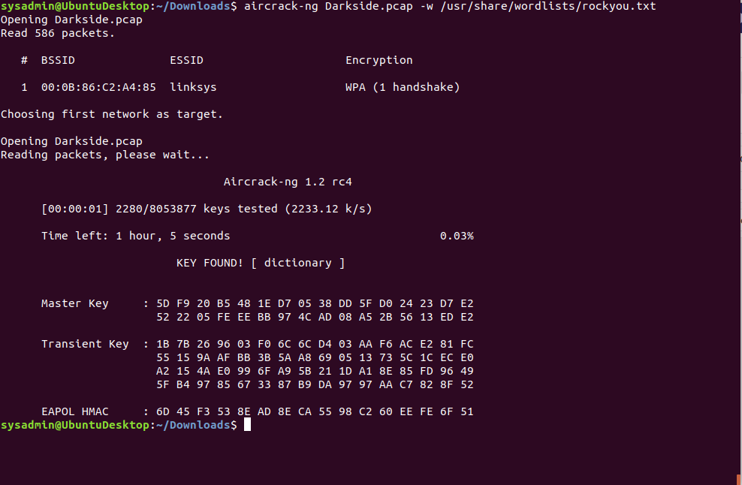
* Use the Dark Side's key to decrypt the wireless traffic in Wireshark.
  + Hint: The format for they key to decrypt wireless is <Wireless_key>:<SSID>.
  + 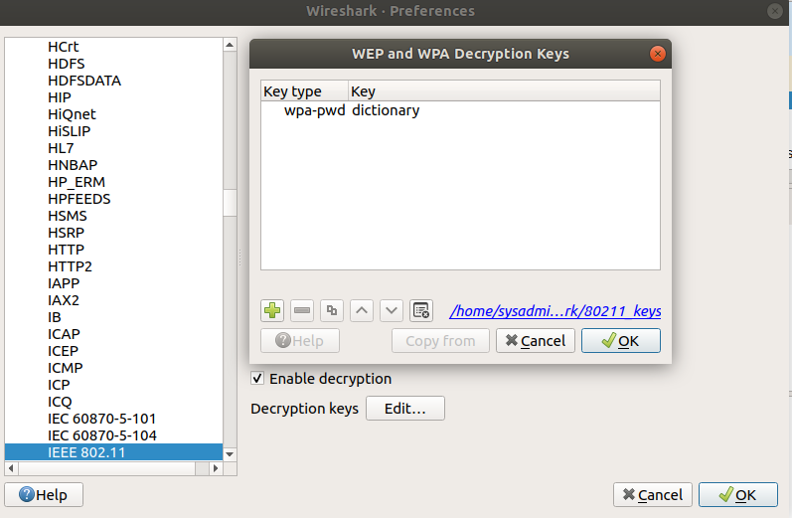
* Once you have decrypted the traffic, figure out the following Dark Side information:
  + Host IP Addresses and MAC Addresses by looking at the decrypted ARP traffic.
  + Document these IP and MAC Addresses, as the resistance will use these IP addresses to launch a retaliatory attack.
  + 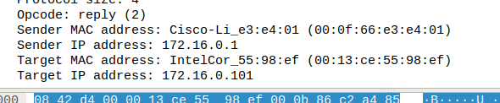

**Mission 7**

As a thank you for saving the galaxy, the Resistance wants to send you a secret message!

Your Mission:

* View the DNS record from Mission #4.
* The Resistance provided you with a hidden message in the TXT record, with several steps to follow.
  + 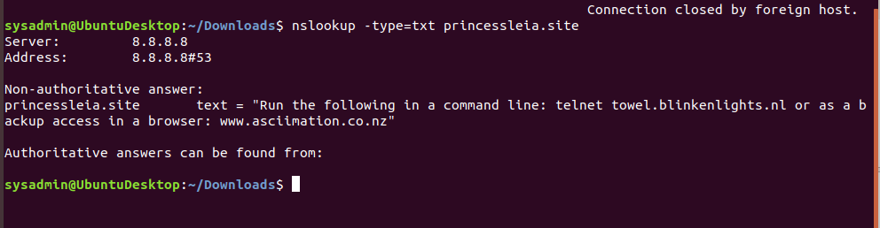
* Follow the steps from the TXT record.
  + **Note**: A backup option is provided in the TXT record (as a website) in case the main telnet site is unavailable
* Take a screen shot of the results.
  + 